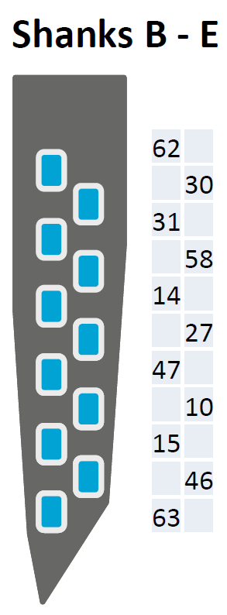
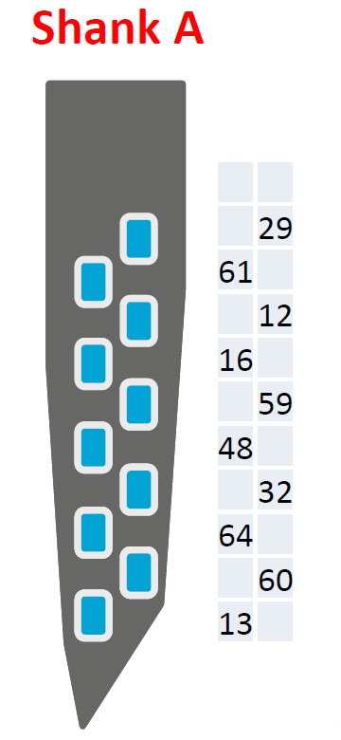

1
2
3
4
5
6
7
8
9
10
12
13
14
15
16
17
18
19
20
21
22
23
24
25
26
27
28
29
30
31
32
33
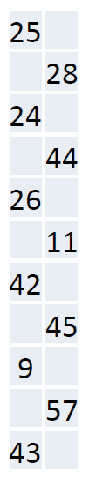

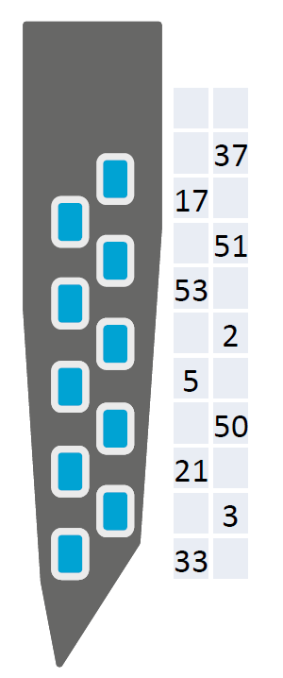
56
57
58
59
60
61
62
63
64
65
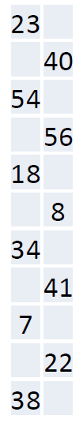
45
46
47
48
49
50
51
52
53
54
55
34
35
36
37
38
39
40
41
42
43
44
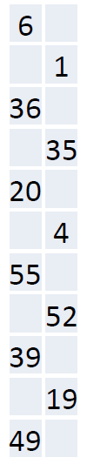

Channel 11 on the Trodes is a dummy channel. We wanted to have the channels of each shank to be on one column in the Tordes.

